**Task No. 1:** Connect 4 switches A, B, C and D, all switches must be password protected (encrypted password) and apply the following configuration, show network topology and

configuration in your lab task.

1. Switch B, C, D must be connected to switch A

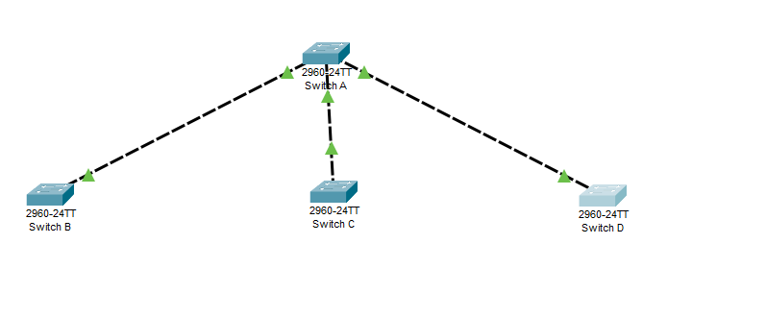

1. Switch B with VLAN name Faculty & Students having 5 logical ports each.

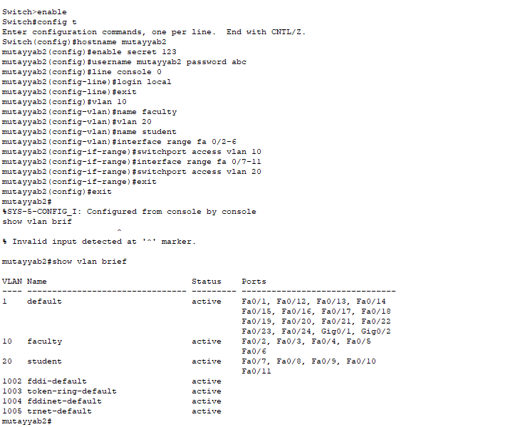

1. Switch C with VLAN name Management having 3 logical ports.

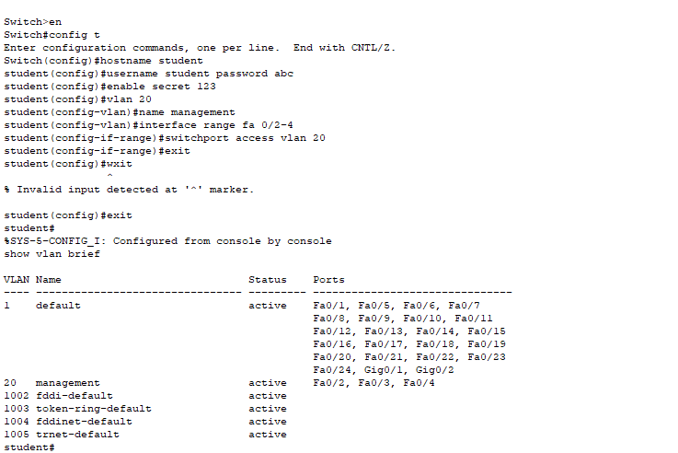

1. 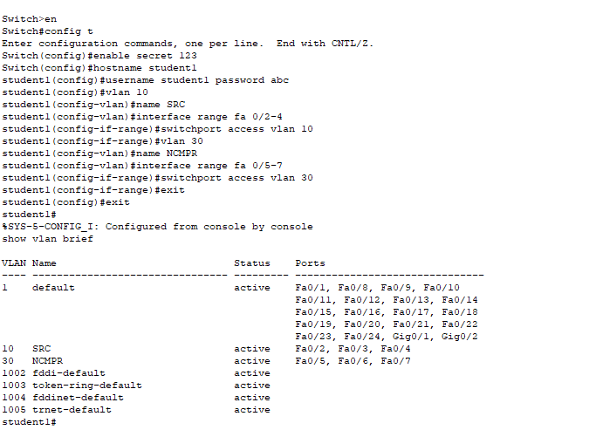Switch D with VLAN name SRC & NCMPR having 3 logical ports each.

e. Choose network IP from Class B for LAN like 172.16.X.X for hosts to test your

LAN network

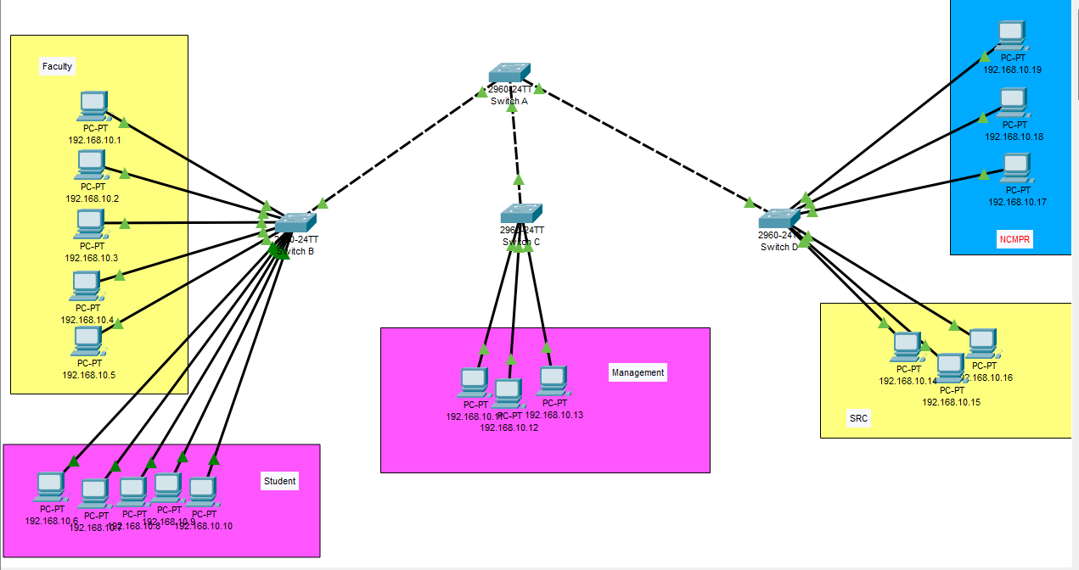

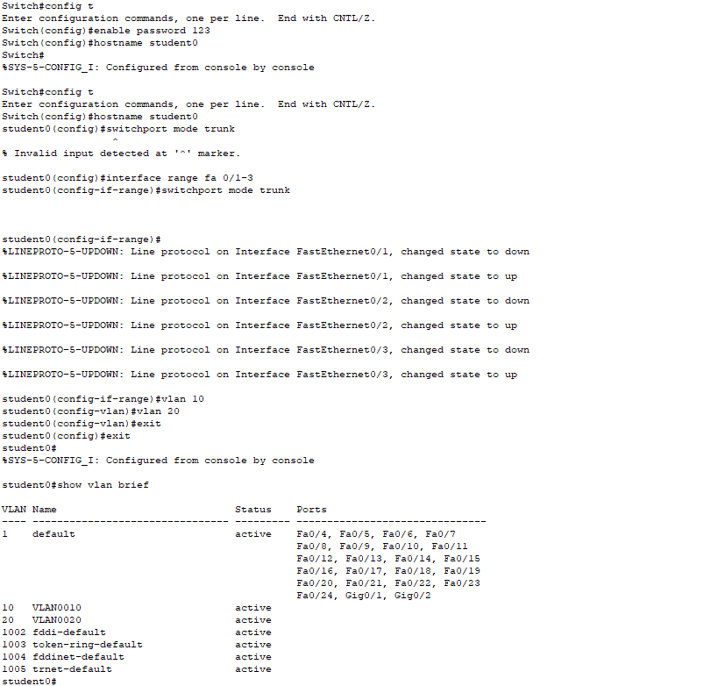

**Solution:**

1. Any PC of VLAN Faculty from any PC connected to switch D VLAN SRC (Ping)

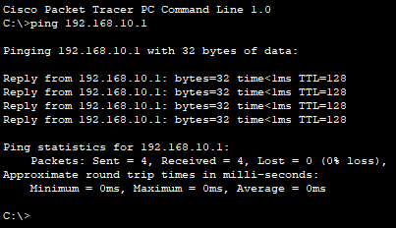

1. 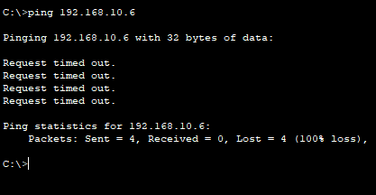Any PC of VLAN student from any PC connected to switch D VLAN SRC (Failed)
2. Any PC of VLAN Student from any PC connected to switch C VLAN Management (Ping)

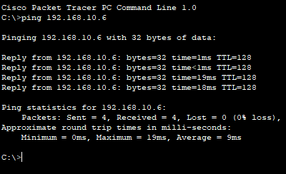

1. Any PC of VLAN Management from same VLAN (ping)

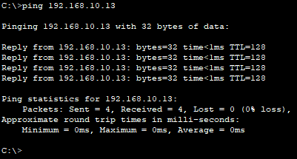

1. VLAN NCMPR from VLAN Student (Failed)

